Experiment No. 5

Feature Scaling Techniques in Machine Learning

1. Aim
To study different feature scaling techniques used in machine learning, specifically Standardization using StandardScaler and Normalization using MinMaxScaler, in order to bring all features to a comparable scale.

2. Objectives
• To understand the concept of feature scaling in machine learning.
• To learn why scaling is required for many machine learning algorithms.
• To study Standardization using StandardScaler.
• To study Normalization using MinMaxScaler.
• To compare the impact of scaling techniques on datasets.

3. Software Required
• Python 3.x
• Jupyter Notebook / Google Colab / Anaconda
• Pandas Library
• NumPy Library
• Scikit-learn Library
• Matplotlib Library

4. Introduction
In machine learning datasets, features often have different ranges and units.
For example:
Feature Range
Age 18 – 60
Salary 20,000 – 1,000,000
If such features are used directly in machine learning models, the algorithm may give more
importance to features with larger values, which can lead to biased results.
To solve this problem, feature scaling is applied.
Feature scaling transforms the values of features so that they fall within a similar range.
This helps improve:
• Model accuracy
• Training speed
• Convergence of optimization algorithms

Feature scaling is especially important for algorithms that rely on distance calculations, such as:
• K-Nearest Neighbors (KNN)
• Support Vector Machine (SVM)
• K-Means Clustering
• Gradient Descent based models

5. Need for Feature Scaling
Feature scaling is required because:
• Features in datasets may have different units and magnitudes.
• Algorithms using distance-based calculations are sensitive to large feature values.
• Large values may dominate smaller values and distort results.
For example:
If one feature ranges between 1–10 and another ranges between 1–10000, the second feature will dominate the model. Feature scaling ensures that each feature contributes equally to the model.

6. Feature Scaling Techniques
Techniques are used for scaling features:
• Standardization (StandardScaler)
• Normalization (MinMaxScaler)

7. Standardization (StandardScaler)
Standardization transforms data so that the mean of the feature becomes 0 and the standard
deviation becomes 1.
This technique converts the data into a standard normal distribution.
Formula
Standardized Value = (X − Mean) / Standard Deviation
Where:
• X = Original value
• Mean = Average value of the feature
• Standard Deviation = Measure of data dispersion
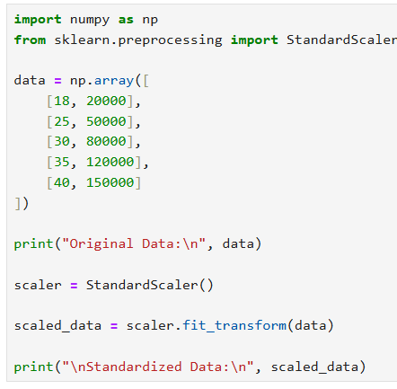
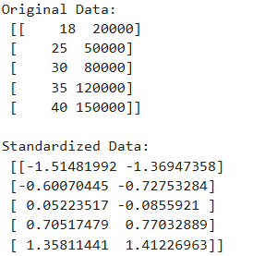

Characteristics of Standardization
• Mean of transformed data becomes 0
• Standard deviation becomes 1
• Data may contain positive and negative values
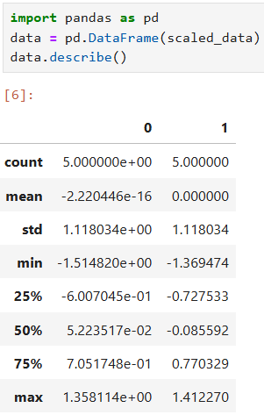

8. Normalization (MinMaxScaler)
Normalization rescales the feature values so that they fall within a fixed range, typically between 0 and 1.
This technique preserves the relative relationship between values while reducing the scale.
Formula
Normalized Value = (X − Min) / (Max − Min)
Where:
• X = Original value
• Min = Minimum value in the feature
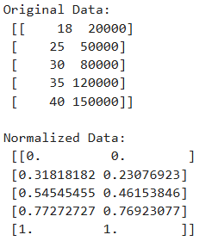
• Max = Maximum value in the feature
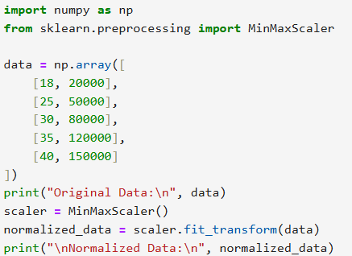

Characteristics of Normalization
• Scales values between 0 and 1
• Maintains relative distribution of data
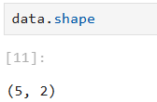
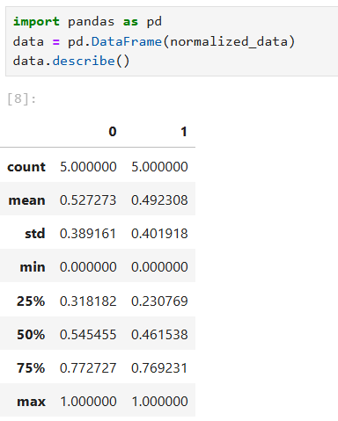
• Does not change the shape of the original distribution

10. Importance of Feature Scaling in Machine Learning
Feature scaling improves machine learning performance by:
• Ensuring equal importance of features
• Improving model convergence speed
• Preventing bias toward large values
• Enhancing accuracy of distance-based algorithms
Without scaling, models may produce incorrect or unstable predictions.

11. Result
The experiment successfully demonstrated the concept of feature scaling using Standardization and Normalization techniques to transform features into comparable scales for machine learning models.

12. Conclusion
Feature scaling is a crucial preprocessing step in machine learning. Techniques such as
StandardScaler and MinMaxScaler help transform feature values into comparable ranges,
improving the accuracy, efficiency, and stability of machine learning models.

Viva Questions – Feature Scaling

1. What is feature scaling?
Feature scaling is a technique used to normalize or standardize feature values so that all features are in a similar range.

2. Why is feature scaling required in machine learning?
- Prevents features with large values from dominating
- Improves model accuracy
- Speeds up training
- Helps in faster convergence

3. What is Standardization?
Standardization transforms data so that:
- Mean = 0
- Standard Deviation = 1

4. What is Normalization?
Normalization rescales data into a fixed range, usually 0 to 1.

5. What is the formula for Standardization?
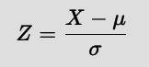

6. What is the formula for MinMax Scaling?
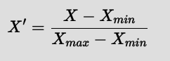

7. What is StandardScaler?
StandardScaler is a Scikit-learn tool used to perform standardization (mean = 0, std = 1).

8. What is MinMaxScaler?
MinMaxScaler is a Scikit-learn tool used to perform normalization (scales data between 0 and 1).

9. Which algorithms require feature scaling?
- K-Nearest Neighbors (KNN)
- Support Vector Machine (SVM)
- K-Means Clustering
- Gradient Descent algorithms

10. Which scaling method is used for KNN?
Normalization (MinMaxScaler) is commonly used because KNN is distance-based.

11. What is the difference between Standardization and Normalization?
Feature | Standardization | Normalization
Range | Not fixed | 0 to 1
Formula | (X - Mean) / Std | (X - Min) / (Max - Min)
Outliers | Handles better | Sensitive
Use case | Normally distributed data | Distance-based models

12. What happens if feature scaling is not applied?
- Model becomes biased toward large values
- Poor accuracy
- Slow training
- Algorithms like KNN and SVM give incorrect results

